**Quantum Sensing Laboratory Parts & Justification**

Beyond fundamental quantum mechanics foundations experiments that have been incorporated into the "Quantum Mechanics for Computer Scientists" (COSC 210), the quantum industry also needs graduates who have an understanding of Applied Quantum Technologies (COSC 315), which can also be considered Quantum Sensing experiments.

As depicted in Fig. 1, there are multiple extraordinary quantum sensing experiments that will be available on a company platform (18"x24").

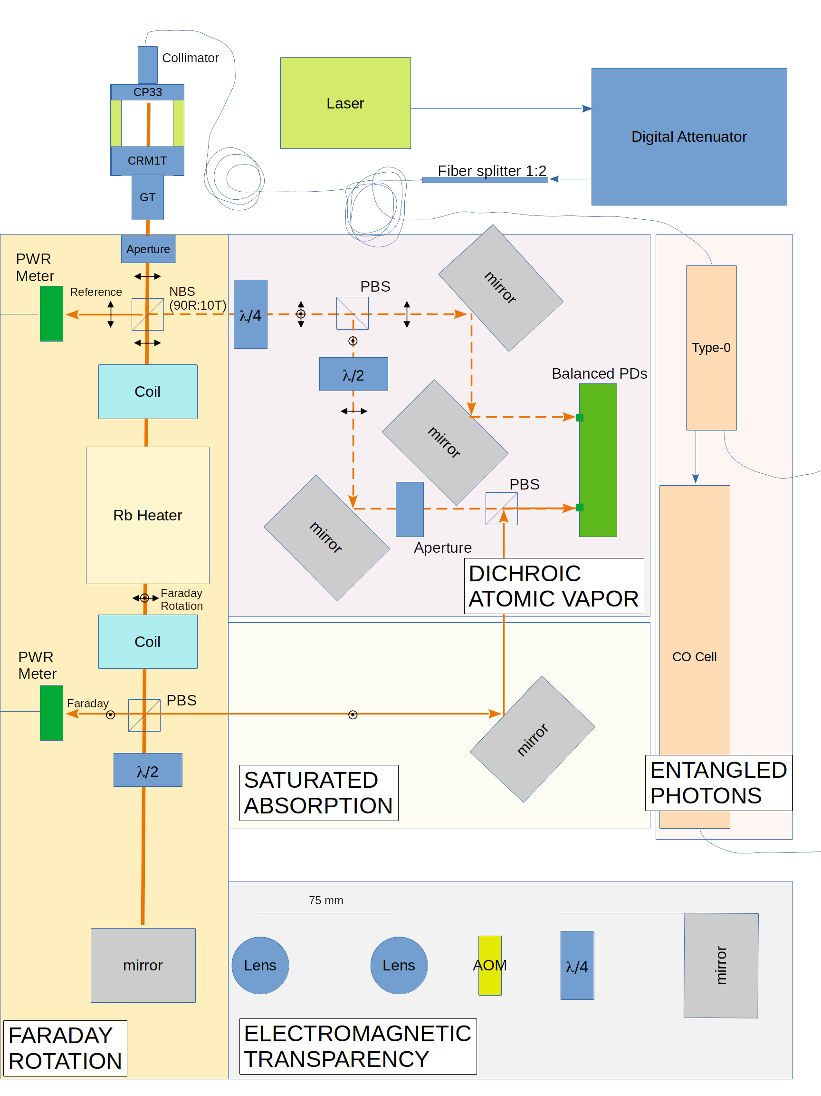**Figure 1.** Optics components and relevant experiments for Applied Quantum Mechanics course (COSC 315).

Detailed below are the components and costs associated with various experiments for the Applied Quantum Technology lab series. These costs are summarized in Table 1, but are broken out further below.

**Table 1.** Totals of different quantum experiments.

|  |  |
| --- | --- |
| **Quantum Experiment Category** | **Cost** |
| Laser Components | $9,833.23 |
| Data Acquisition and Opto-mechanics | $10,331.65 |
| Faraday Rotation | $7,004.11 |
| Spectroscopy (SAS and DAVS) | $4,726.24 |
| Electromagnetic Induced Transparency | $15,476.17 |
| Hyper-entangled photons (home-built option) | $77,474.34 ($47,000) |
| **TOTAL** | **$124,845 ($94,371)** |

The 18"x24" aluminum optics table and laser tuned for 780.2 nm to target the Rb-85 D2 spectroscopic line (and light attenuation components), totals **$9,833.23** (including 6% Md tax), as shown in Table 2.

**Table 2.** Laser 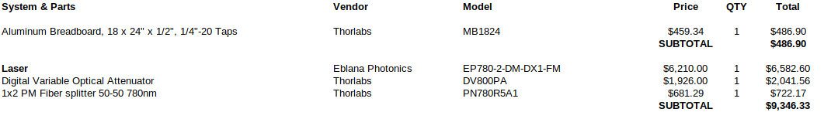components for quantum sensing experiments.

Other components needed in general for these experiments are detailed in Table 3, totaling **$10,331.65** (including 6% Md tax). These components include data acquisition, opto-mechanics, and basic laser and magnetic field diagnostics.

**Table 3.** Other components needed for the underlying quantum experiment infrastructure.

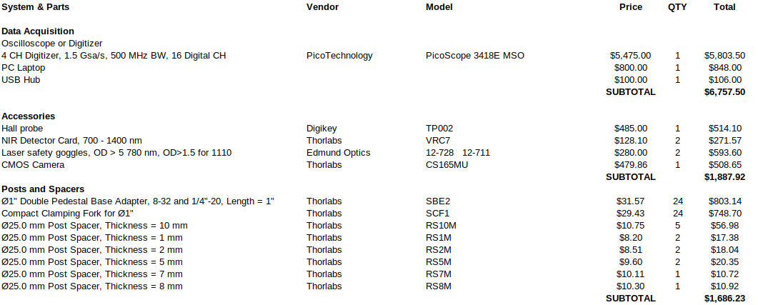

A primary experiment for students to understand is the concept of Faraday rotation. With Faraday rotation, the angle of the laser beam's polarization rotates when an alkali gas (i.e. rubidium) is exposed to an applied magnetic field. By measuring the angle of this rotation, the applied magnetic field can be calculated. Hence, the quantum concept of Faraday rotation can be used to create a quantum magnetometer. The setup for this Faraday rotation experiment is shown on the left side of Fig. 1. As shown in Table 4, the optical components and cost totals **$7,004.11** (including 6% Md tax).

**Table 4.** Faraday rotation components

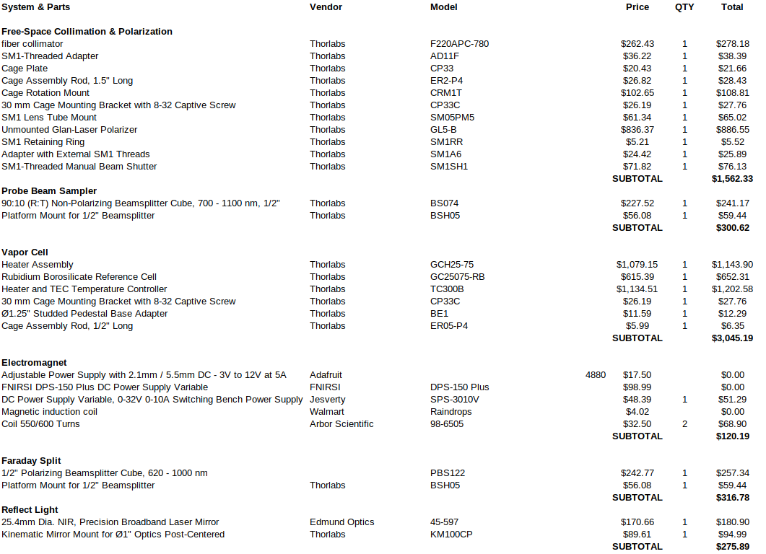

Using most of the same components from the Faraday rotation/magnetometer setup, we can also conduct Saturated Absorption Spectroscopy (SAS) and Dichroic Atomic Vapor Spectroscopy (DAVS), as also shown in Fig. 1. The extra cost to add these optical components is **$4,726.24** (including 6% Md tax), as shown in Table 5.

**Table 5.** Additional components needed to conduct SAS and DAVS quantum experiments.

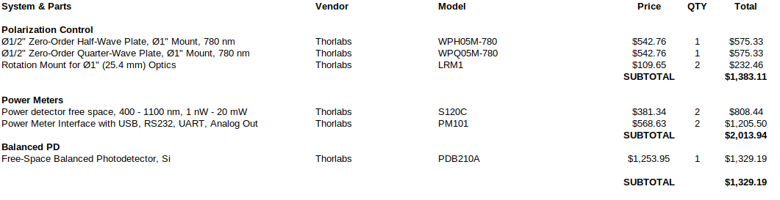

An amazing quantum effect is known as Electromagnetic Induced Transparency (EIT), also known as Coherent Population Trapping (CPT). When a pump laser traverses an alkali gas (i.e. rubidium), and then a frequency-shifted reflected beam passes back through the gas at the resonance frequency of the Zeeman-shifted hyperfine ground states of Rb, the gas stops absorbing (hence, "transparency"). This induced transparency can be used as a more precise magnetometer than Faraday rotation, because the applied magnetic field causes a very narrow resonance for EIT to occur, and therefore a very precise magnetometer by adjusting the frequency of the reflected "probe" beam. The additional "frequency shifter" components needed for this set of experiments are shown at the bottom of Fig. 4. The cost for the frequency shifter is **$15,476.17** (including 6% Md tax), as detailed in Table 6.

**Table 6.** Components for a frequency shifter that will allow for EIT experiments and a more precise magnetometer experiments.

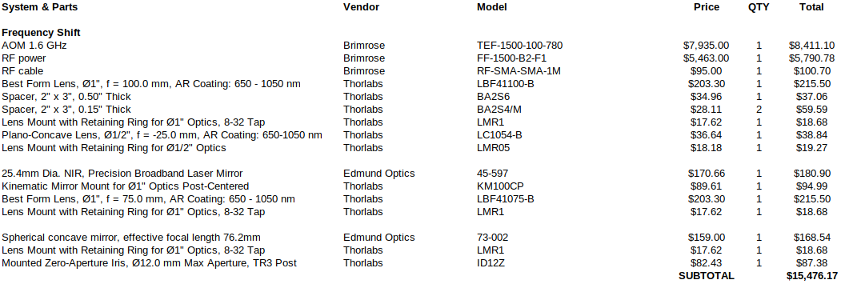

A very important concept for quantum technology going forward is the quantum entanglement. Two photons can be created that are entangled, either by polarization (horizontal and vertical polarizations) or time-energy (two different wavelength photons generated at same time). Multiple important quantum technology experiments can be developed for entangled photons, including ghost spectroscopy and entangled Quantum Key Distribution. However, the hardware needed for infrared photons can be expensive.

The added components to generate hyper-entangled photons (polarization and wavelength) are shown on the right side of Fig. 1. The cost for these additional components is **$77,474.34** (including 6% Md tax), as detailed in Table 7. Please note that two Avalanche Photo-Diodes (APDs) operating in the infrared (IR) are needed for these experiments. Unfortunately, there are only a few vendors who make turn-key IR APDs, and the cost is about $20,000 each. However, the actual IR APD sensor is only $450. Often universities will make their own electronics for the APD sensors at much lower cost than these turn-key vendors. As such, we believe we could reduce the total cost for hyper-entangled photons by about $30,000 if build the electronics ourselves (grand total of about **$47,000**).

Entangled photons are a very important quantum tool being used by industry, so we believe this entangled photon source should be pursued. Additionally, our entangled photons will be in the important Super-C (1510 nm -1560 nm) and Super-L (1560 nm - 1610 nm) wavelengths, which are used by the telecommunications industry. Students competent at using entangled photons in the C- and L- bands is very important for the quantum industry and future quantum technology research.

**Table 7.** Components and costs to generate hyper-entangled photons and their detection.

